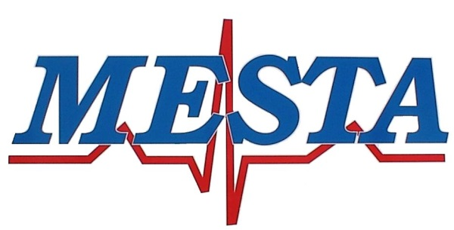

918-825-6825 Phone 918-825-6829 Fax

NOTICE
Pursuant to, and in accordance with Oklahoma Statues Title 25, Section 311, notice is hereby given of the regularly scheduled meeting of the Mayes Emergency Services Trust Authority at 5:00PM December 12th, 2023, at the MESTA Main Station #1, 4144 Redden Street, Pryor, Oklahoma.

AGENDA

- Call to order.
- Consent agenda
- Regular Board Meeting Minutes of November 14th, 2023
- Financial Statement of November 2023
- Claims for payment
- Request for Blanket purchase orders
- Transfer of funds necessary to cover expense
- Attorney report
- Director report

Regular Agenda

- New Business: Consideration and possible Board action with respect to any other matters not known about or which could not have been reasonably foreseen prior to posting the agenda.
- Discussion and possible Board action on a report from the Executive Director Search Committee
- Discussion and possible Board action on approving the annual budget of the Authority for FY 2024
- Discussion and possible Board action on payment to Stryker for current services rendered or purchasing an annual PM agreement
- Citizens input, open to all Citizens limited to 2 minutes per individual.
- Adjournment.

Posted December 8th, 2023

Brandon Hawkins

Director of MESTA

