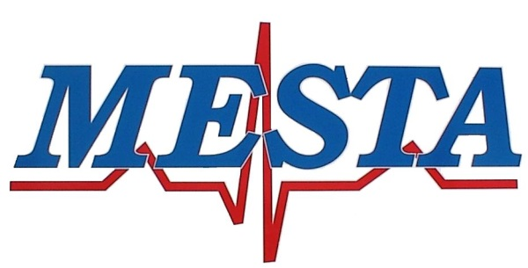

918-825-6825 Phone 918-825-6829 Fax

NOTICE
Pursuant to, and in accordance with Oklahoma Statues Title 25, Section 311, notice is hereby given of the regularly scheduled meeting of the Mayes Emergency Services Trust Authority at 5:00PM March 12^{th,} 2024, at the MESTA Main Station #1, 4144 Redden Street, Pryor, Oklahoma.

AGENDA

- Call to order.
- Consent agenda
- Regular Board Meeting Minutes of February 13th, 2024
- Financial Statement of February 2024
- Claims for payment
- Request for Blanket purchase orders
- Transfer of funds necessary to cover expense
- Attorney report
- Director report

Regular Agenda

- New Business: Consideration and possible Board action with respect to any other matters not known about or which could not have been reasonably foreseen prior to posting the agenda.
- Discussion and possible Board action on purchasing 6 Sapphire IV pumps from Henry Schein at a total cost of $12.090.00
- Discussion and possible Board action on selling three (3) MESTA vehicles, specifically Unit #70 2008 General Motor van VIN #1GCHG396981231198, Ford Expedition 2013 VIN #1FMJK1G56DEF35232, and Unit #67 2008 ford E series 1FDXE45P19DA25763 to be sold on the auction website Purple Wave.
- Discussion and possible Board action on the purchasing of a new 2023 Ford F150, Quote #000Q13577 at a cost of $45,277.00 from John Vance Fleet services. This is to replace the Ford expedition that has over 200,00 miles on it.
- Discussion and possible Board action on an executive session of the Board, as authorized by Title 25, Section 307 B.1 of the Oklahoma Statutes, for the purpose of discussing the employment, appointment, promotion, demotion, disciplining, or resignation of Bradley A. Reed Executive Director of the Authority, including his job performance.
- After a return by the Board of Trustees to the public meeting, discussion, and possible action on any item of business considered during the Executive Session.
- Discussion and possible Board action on an executive session of the Board, as authorized by Title 25, Section 307 B.1 of the Oklahoma Statutes, for the purpose of discussing the employment, appointment, promotion, demotion, disciplining, or resignation of Brandon Hawkins.
- After a return by the Board of Trustees to the public meeting, discussion, and possible action on any item of business considered during the Executive Session.
- Discussion and possible Board action on an executive session of the Board, as authorized by Title 25, Section 307 B.1 of the Oklahoma Statutes, for the purpose of discussing the employment, appointment, promotion, demotion, disciplining, or resignation of Hanna McCaslin, including the appeal of their termination.
- Discussion and possible Board action on an executive session of the Board, as authorized by Title 25, Section 307 B.1 of the Oklahoma Statutes, for the purpose of discussing the employment, appointment, promotion, demotion, disciplining, or resignation of Amanda Early, including the appeal of their termination
- After a return by the Board of Trustees to the public meeting, discussion, and possible action on any item of business considered during the Executive Session.
- Citizen’s input, open to all Citizens limited to 2 minutes per individual.
- Adjournment.

Posted March 8th, 2024

Bradley Reed

Director of MESTA

